Sunshine American Primary School
Week 2 (Grammar 17+School Subject Reading Unit1+2)
Date: ______ Class: ____ Mark: ________English Name: ____________________
A. Read the leaflet and answer the questions. (5%)
Monday morning:
Music Mania
Everyone talk about his own favorite songs or bands!
Wednesday afternoon:
Sports Special
Play your favorite sport and learn new ones.
Tuesday night:
Reading Adventure
Read all kinds of ghost stories and watch scary movies.

The Incredible Club!
Thursday morning:
Computer Carnival
Play on the computers!
Learn about the internet!
Friday:
Terrific Trips
Come on outing with us.
Visit all the amusement parks in Taiwan.

 | ( ) | 1. | Jane likes rides in amusement parks, so what day does she want to go to the club?
 |  |  | (a) Monday | (b) Friday | (c) Thursday
 | ( ) | 2. | Sam is really scared of dark and scary things, so what day does he never join the club?
 |  |  | (a) Tuesday | (b) Thursday | (c) Wednesday
 | ( ) | 3. | Peter joins sports club and music club, so what does he need to bring on Monday?
 |  |  | (a) Stories books | (b) A ball | (c) CDs
 | ( ) | 4. | Mary joins swimming and computer games so what days does she have to go to the club?
 |  |  | (a) Thu. and Wed. | (b) Mon. and Fri. | (c) Tue. And Wed.
 | ( ) | 5. | What day does Mina need to take all day to do in the club?
 |  |  | (a) Tuesday | (b) Wednesday | (c) Friday
B. Fill in the correct answer. (60%)
dentist | grown-up | cinema
tennis | toast | chicken
guitar | basketball | put in
coffee | shake | beach
doll | karaoke | movie star
cheese | clothes | burger
computer | tuna | sandwich
chill | Australia | lemonade
orange juice | famous | problem
television | football | ice cream

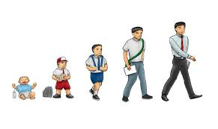 |  |  | 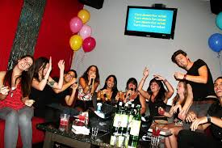 | 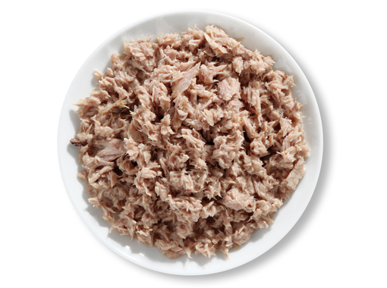
 | 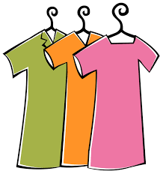 | 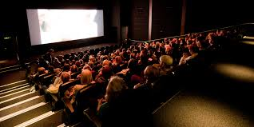 | 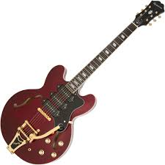 | 
 | 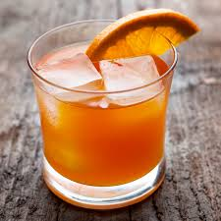 | 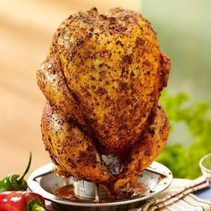 | 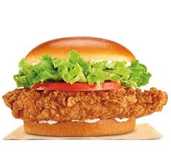 | 
 |  |  | 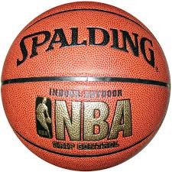 | 
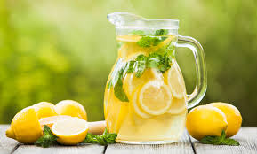 | 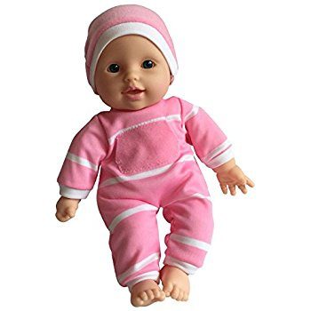 | 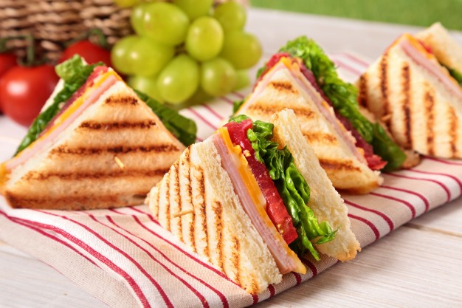 |  | 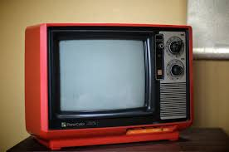
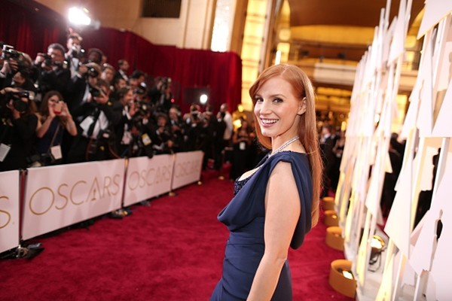 | 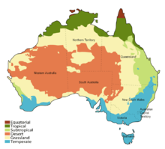 |  | 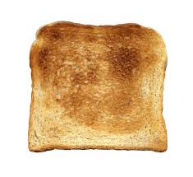 | 

C. Grammar practice (35%)
For example:

(he, some apple juice) O

Would he like some apple juice?
Yes, he would.
He would like some apple juice. = He’d like some apple juice.

(I, read a novel) X I would like to read a novel.

Would I like to read a novel?
No, I wouldn’t.
I wouldn’t like to read a novel.

1.(they, play basketball) O
?

=

2.(she, coffee) O
?

=

3.(you, go to the theater) X
?

=

4.(it, meat) O

?

=

5.(we, have a travel) X

?

=

