Sunshine American Primary School
Week 3 (Grammar 18+School Subject Reading Unit 3)
Date: ______ Class: ____ Mark: ________English Name: ____________________
A. Read the following stories and choose the correct answers.
Making Jelly

Cindy is going to make jelly. She puts the pieces of jelly into a big bowl and asks her mother to help her pour hot water into the bowl. She uses a spoon to stir the mixture until the pieces of jelly have disappeared. Cindy then pours the jelly into six cups.
Her mother helps her put the cups of jelly into the refrigerator. She tells Cindy that she will have to wait until the jelly hardens before she can eat it. Cindy is very excited. She can’t wait to eat her homemade jelly.

( ) | 1. | Cindy is going to make _______________
 |  | (a) jelly | (b) toast | (c) cake | (d) lemonade
( ) | 2. | Cindy’s mother helps her ___________________
 |  | (a) pour cold water.  (c) hold the bowl |  | (b) pour milk  (d) pour hot water
( ) | 3. | Cindy used a ______________ to mix the jelly and water.
 |  | (a) fork | (b) knife | (c) spoon | (d) chopsticks
( ) | 4. | Hot water makes the jelly pieces ________________.
 |  | (a) bigger (b) disappear (c) smaller (d) longer
( ) | 5. | The jelly is put in the refrigerator to ______________.
 |  | (a) freeze (b) harden (c) soften (d) cook

B. Fill in the correct answer.
puppy | vegetable | boring
bread | white | carrot
fur coat | fur | rubber ball
sneaker | clean | paint
potato | maths | soft

 |  | 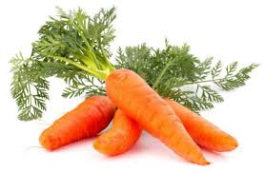 |  | 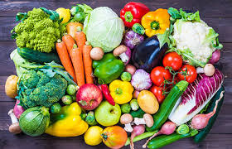
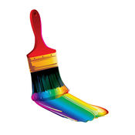 |  | 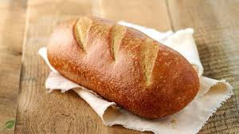 | 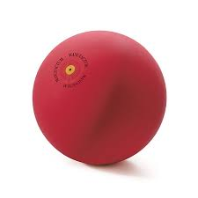 | 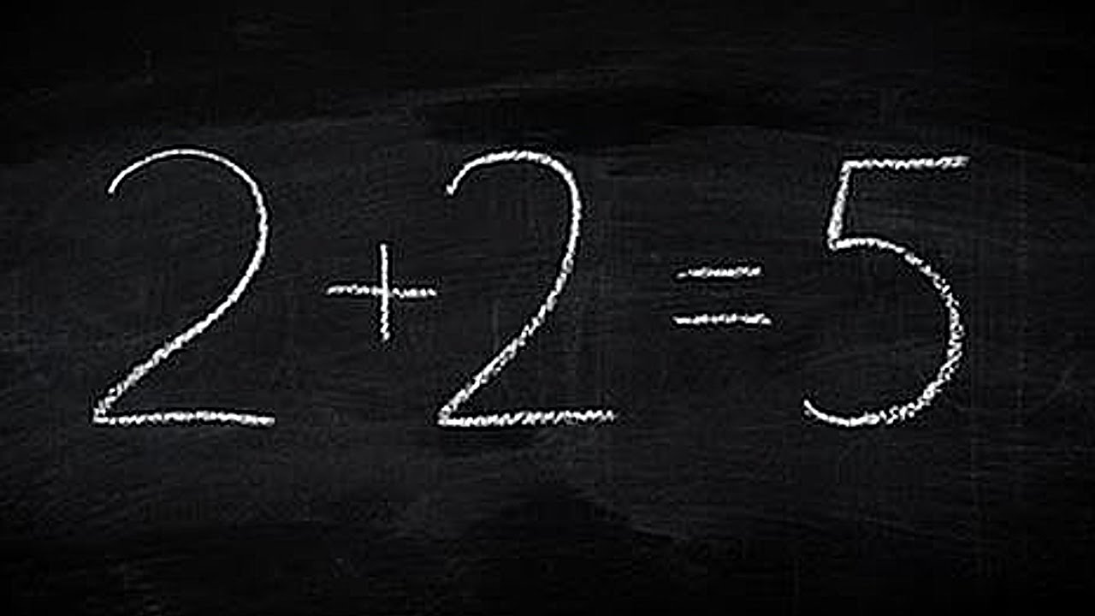
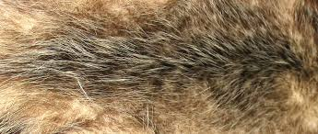 | 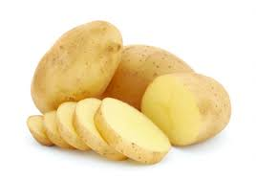 | 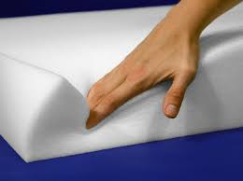 | 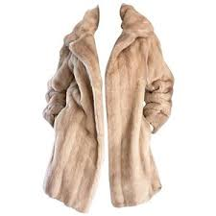 | 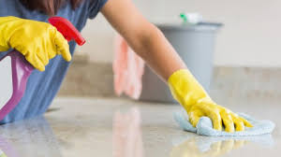
C. Grammar practice
For example:
( he, drink some apple juice) O
Does he like drinking some apple juice?
Yes, he does.
He likes drinking some apple juice.
1.(they, play basketball) O
?

2.(she, get up early) X
?

