Sunshine American Primary School
Week 4 (School Subject reading Unit 4, grammar Unit 19 )
Date: ________________ Class: ___________English Name: ____________________
A. Read the following stories and choose the correct answers.
Clubs

There are all kinds of clubs for people of all ages. Some are for music lovers. Others are for hiking. There are even clubs for making arts. People with similar interests join clubs. It’s a good way to meet people.
To get new members, clubs have special activities. They make big posters. They also hold parties. Club members tell other people about the club. They display photos, pictures, and examples of what the club does.

( ) | 1. | Clubs are nice for _______________.
 |  | (a) young people only  (c) schools |  | (b) meeting people  (d) people with very different interests
( ) | 2. | The article does not mention clubs for ______________
 |  | (a) computers | (b) hiking | (c) music | (d) art
( ) | 3. | What does “of all ages” mean?
 |  | (a) very old  (c) about 25 years old |  | (b) from young to old  (d) at a special age
( ) | 4. | How do clubs attract new members?
 |  | (a) They send them photos.  (c) They sell posters. |  | (b) They give them money.  (d) They hold activities.
( ) | 5. | Why do people join the clubs?
(a) Because they want to have parties.
(b) Because they want to get new members.
(c) Because they have same interests.
(d) Because they like to tell other people about the club.

B. Read the following stories and choose the correct answers.

Jay Chou
Jay Chou is a creative young singer from Taiwan. He is popular in many Asian countries. Jay sings R&B and rap music. He writes personal songs about his life. Plus, Jay plays the guitar, piano, and cello very well. He is very talented.
Jay often wins awards for his music. His CDs are very big sellers. And, his concerts are always full of fans. This young singer is a leader in modern Chinese music.

( ) 1. Jay is .
(a) only popular in Taiwan (b) good at playing instruments
(c) from many Asian countries (d) not a song writer
( ) 2. What does “talented” mean?
(a) good at doing something (b) rich
(c) lonely (d) popular and creative
( ) 3. Jay does NOT play the .
(a) cello (b) guitar
(c) piano (d) violin
( ) 4. Jay is a CREATIVE young singer so he can .
(a) sing R&B and rap songs
(b) write a lot of new songs
(c) play the guitar, piano, and cello very well
(d) do above all
( ) 5. Which of the following is true?
(a) Jay almost never wins awards.
(b) Jay only sings rap songs.
(c) Many people buy Jay’s CDs.
(d) Jay doesn’t like writing about himself.

C. Choose the correct answer. Write the letter (a, b or c) in the brackets.
( )1. Would you like a cup of tea? No, _____________
(a) I’d (b) I wouldn’t (c) I’d like
( )2.Would Andy_________ ice cream?
(a) like to (b) to like (c) like
( )3.A: Would you like to read a magazine? B:________________
(a) Yes, I’d like. (b)No, I wouldn’t. (c) Yes, I would like to.
( )4.Katy__________ for breakfast.
(a) would like an egg (b) would likes an egg (c) would like to an egg
( )5.Sarah___________learn the guitar.
(a)want to (b)would like (c) wants to
( )6.Dennis___________Australia.
(a) like to visit (b) would like go to (c) would like to visit
( )7.A:_______________some tea? B: Yes, I would.
(a)Would you like to (b)Would you likes to (c) Would you like
( )8.The boy______________.
(a)like play (b)would like the toy (c) would like to the ball
( )9._____________to a party?
(a)Would you like to come (b)would you like to come (c) We’d like to go
( )10.Which of the following is CORRECT?
(a)We would like to some comic books.
(b)Would Ted and Amy like to listen to music?
(c)The children would like some cookies.

D. Fill in the correct answer.
lunch | permission | throw the javelin
haircut | alone | dive
music | uniform | lend
sad | go skiing | do gymnastic
cool | article | option

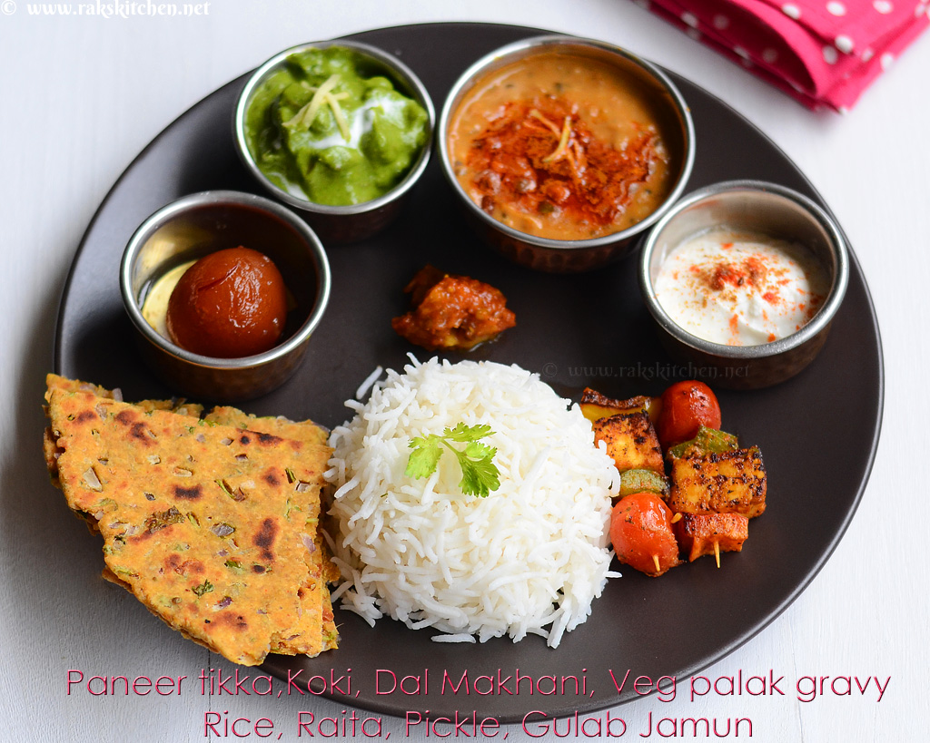 |  |  |  | 
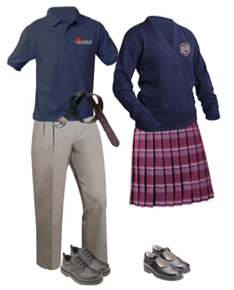 |  |  |  | 
 |  |  | 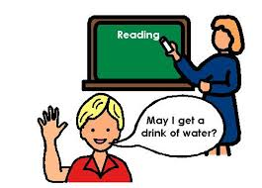 | 

