Sunshine American Primary School-Evening Class
Week 7 homework (Oxford Grammar 1 U17-21, SSR1 U1-6, )
Class: ______________ English Name: ____________ Chinese Name:
A. Choose the correct answer. Write the letter (a, b or c) in the brackets.
( ) | 1. | A: Would you like a burger? B: _______________
 |  | (a) No, thanks. I like cheese.
 |  | (b) Yes, please. I’d like a burger.
 |  | (c) No, thanks. I’d some hot chocolate. |  |  |  | (c) He’d likes to play
( ) | 2. | Which of the following is CORRECT? (2%) |  |  |  | (c) I would
 |  | (a) We would like to some | comic books.
(b) Would Ted and Amy like listen to music?
(c) The children would like some cookies.

( ) | 3. | Sarah _______________ learn the guitar.  (a) like to (b) wants to (c) would like
 |  |  |  |  |  | (c) to like
 |  |  |  |  |  | (c) to like
( ) | 4. | She’d ______________ a cake for herself.  (a) like to make (b) likes make (c) likes to make
 |  |  |  |  |  | (c) Yes, I’d like.
 |  |  |  |  |  | (c) Yes, I’d like.
( ) | 5. | _______________ some cheese.  (a) Annie likes to (b) Mom can buy (c) Sam would likes
 |  |  |  |  |  | (c) would like to be
 |  |  |  |  |  | (c) would like to be
( ) | 6. | __________ is not easy.  (a) Learning English (b) Ride a horse(c) Do mathing
( ) | 7. | Does Tina like wearing new clothes?  - Yes, she do.  - No, she likes wearing new clothes.  - No, she likes listening to the music.
( ) | 8. | Can her sister fly a kite?  (a)Yes, she do. (b)No, she doesn’t. (c)No, she cannot.
( ) | 9. | Which is my bag?  - Your bag is on your chair.  - This is your bag.  (c)Your bag is not here.
( ) | 10. | What is this?  - This is a cat.  - She is my sister.  - There is a mouse.

B. Read the following stories and choose the correct answers. (20%)
Reading 1
My name is Sachiko. I am 10 years old. I am from Japan. My family moved to
Taiwan last year because my father is working here. I now go to Mingshen Elementary School.

I can’t speak Chinese well, but my teacher, Mrs. Huang, teaches me Chinese.
She is a very nice teacher. I also meet lots of friends in my class. All of them are Chinese. They teach me Chinese, too. They also tell me many interesting things
about Taiwan. We often have fun together after school. I really love it there.

Read the story above and choose the correct answers.
( ) | 1. | Who is “Sachiko”?
 |  | (a) A Chinese person.
 |  | (b) A new teacher.
 |  | (c) A new student in Mingshen Elementary School.
 |  | (d) A Chinese teacher.
( ) | 2. | Where is Sachiko from? She is from _________________.
 |  | (a) China | (b) Japan | (c) Taiwan | (d) We don’t know.
( ) | 3. | Why does Sachiko go to Mingshen Elementary School?  It's because ____________________________________.
 |  | (a) she loves to go to Mingshen Elementary School
 |  | (b) her good friends go to Mingshen Elementary School
 |  | (c) her Chinese teacher is in Mingshen Elementary School
 |  | (d) her family moved to Taiwan last year
( ) | 4. | Who is Mrs. Haung?
 |  | (a) She is Sachiko’s Chinese teacher. |  | (b) She is my friend.
 |  | (c) She is Sachiko’s Japanese teacher. |  | (d) She is Sachiko’s classmate.
( ) | 5. | Which of the following is NOT TRUE?
 |  | (a) Sachiko loves many things in Taiwan.
 |  | (b) Sachiko meets many friends in new school.
 |  | (c) Sachiko can’t speak good Chinese.
 |  | (d) Sachiko is an English boy.

Reading 2
Ted:  Sally:  Ted:  Sally:  Ted:  Sally:  Ted:  Sally:  Ted:  Sally: | Helen’s birthday is coming soon.  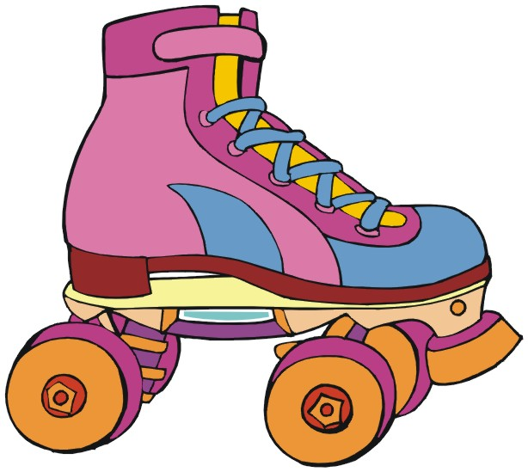  What are you going to buy for her?  Well, I have no idea.  How about a pair of roller-skates?  I don’t think it’s a good idea. She can’t roller-skate at all.  Then, how about a bicycle? She often goes to school by bicycle.  No, she already has one.  I know. But it’s old. We can buy her a new one.  O.K. Maybe you’re right.  Her bicycle looks old and a little small for her.  Then, why not go to Super Sports Store tonight?  They have a big sale now.  Great! See you tonight at Super Sports Store.

Read the dialogue above and choose the correct answers.
( ) | 1. | What are Sally and Ted going to buy for Helen?
 |  | (a) A pair of roller-skate. | (b) A comic book.
 |  | (c) A bicycle. | (d) A dress.
( ) | 2. | What can Helen do? She can _________________.
 |  | (a) cook delicious food | (b) play basketball
 |  | (c) roller-skate | (d) ride a bike
( ) | 3. | Where are Sally and Ted going tonight?
 |  | (a) To the gym. | (b) To Super Sports Store.
 |  | (c) To the park. | (d) To Helen’s party.
( ) | 4. | Who often goes to school by bicycle?
 |  | (a) Ted. | (b) Sally.
 |  | (c) Helen. | (d) Ted, Sally and Helen.

