Sunshine American Primary School-Evening Class
Week 17 Homework

- Choose the correct answer. Write the letter (a, b or c) in the brackets.
 | ( ) |  | 1. |  | Peter would like to go shopping ________ he doesn’t have any money.
 |  |  |  |  | (a) but |  |  |  | (b) and |  |  |  | (c) or
 | ( ) |  | 2. |  | Their __________.
 |  |  |  |  | (a) dog are beautiful |  |  |  | (b) jackets are blue |  |  |  | (c) shoes is new
 | ( ) |  | 3. |  | There are some toys _________ the beach.
 |  |  |  |  | (a) in |  |  |  | (b) on |  |  |  | (c) under
 | ( ) |  | 4. |  | I like playing hockey _______ winter.
 |  |  |  |  | (a) at |  |  |  | (b) on |  |  |  | (c) in
 | ( ) |  | 5. |  | there your ?
 |  |  |  |  | (a) Are, nifes |  |  | (b) Is, boxes |  |  | (c) Are, families
( ) |  |  |  | 6. |  | Which one is correct?
 |  |  |  |  |  | (a) boies | (b) keys |  |  | (c) womans
( ) |  |  |  | 7. |  | Don’t stand _______ a tree during a thunder storm.
 |  |  |  |  |  | (a) in | (b) behind |  |  | (c) under
 | ( ) |  | 8. |  | The juice is ____________ the popcorn.
 |  |  |  |  | (a) under |  |  | (b) behind |  |  | (c) at
 | ( ) |  | 9. |  | The pizza is ____________ the table.
 |  |  |  |  | (a) under |  |  | 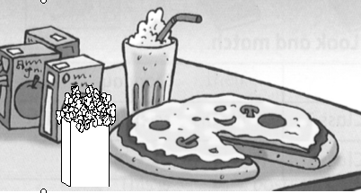  (b) on |  |  | (c) at
 | ( ) |  | 10. |  | 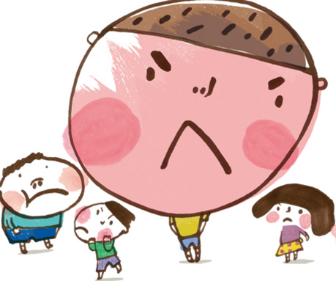  What __________ !
 |  |  |  |  | (a) a angry boy |  |  | (b) a boy angry |  |  | (c) boy angry
( ) |  | 11. |  | ______________ women on the bus.
(a) They’re
(b) There is
(c) There aren’t
( ) |  | 12. |  | ___________ mice in the cage?
(a) Is there
(b) Are there
(c) Are they
Please write a small story with “There is” or “There are”.

- Read the following stories , draw the lines and choose the correct answers.
A Sudden Flood
One day while I was watching TV, suddenly, it started to rain heavily. After half an hour, the rain was leaking in from the door and the window. There was more and more rain in the house. The heavy rain floated all of the light things in the house, like buckets, bottles, cups, and so on. We were so scared and didn’t know what to do. All my family climbed up on the roof. We saw many things floating here and there. The flood was almost six feet deep. That night we were both hungry and cold on the roof. It was a long night for us to wait for help. The next morning, the rain stopped, and then the flood went down. We climbed down and got into the house. Everything was still there, but there was dirt everywhere. We spent one week washing everything. Now we have a new three-story house. It’s much safer when a storm comes.

( ) | 1. What was the writer doing when it started to rain heavily?
 |  | (a) He was sleeping. | (b) He was cooking.
 |  | (c) He was writing. | (d) He was watching TV.
( ) | 2. What floated in the writer’s house in the flood?
 |  | (a) cars | (b) bottles
 |  | (c) ducks | (d) TV sets
( ) | 3. Where was the family during the flood?
 |  | (a) In the mountains. | (b) On the second floor.
 |  | (c) Out. | (d) On the roof.
( ) | 4. How long did they spend washing everything in their house?
 |  | (a) One year. | (b) One month.
 |  | (c) Seven weeks. | (d) Seven days.
( ) | 5. What did they lose in the flood?
 |  | (a) Their life. | (b) Their house.
 |  | (c) Nothing. | (d) Their car.

